Comparing Models of Subject-Clustered

Single-Cell Data

### Lee Panter

#### Audrey Hendricks*, PhD-Committee Chair and Advisor Stephanie Santorico∗, PhD-Committee Member

#### Rhonda Bacher†, PhD-Committee Member

# 1 Abstract

###### Single-Cell RNA sequencing data represents a revolutionary shift to approaches being used to decode the human transcriptome. Such data are becoming more prevalent and are gathered on ever-larger samples of individuals, enabling analysis of subject level relationships. However, it is not always clear how to conduct this subject level analysis. Current methods often do not account for nested study designs in which samples of hundreds, or thousands of cells are gathered from multiple individuals. Therefore, there is a need to outline, analyze, and compare methods for estimating subject level relationships in single-cell RNA sequencing expression.

###### Here, I compare five modeling strategies for detecting subject level associations using single- cell RNA sequencing expression: linear modeling, linear modeling with subjects modeled as fixed effects, linear mixed effects models with subjects modeled as random intercepts only or both random intercepts and random slopes, and generalized estimating equations. I first present each method. I then compare the regression estimates and standard errors for each method using real single-cell data from a Lupus Nephritis study of 27 subjects. I hope that this paper presents insights into methods to analyze subject level associations from single-cell expression data.

∗The University of Colorado-Denver

†The University of Florida

**Contents**

1. Abstract 1
2. Introduction 3
3. Description of Data Set 4
4. Model Descriptions 5

4.1 Linear Model (LM) . . . . . . . . . . . . . . . . . . . . . . . . . . . . . . . . 6

4.2 Linear Model with Fixed-Effect (LM-FE) . . . . . . . . . . . . . . . . . . . . 6

4.3 Linear Mixed Effects Models . . . . . . . . . . . . . . . . . . . . . . . . . . . 7

* 1. Generalized Estimating Equations (GEE) . . . . . . . . . . . . . . . . . . . . 8
  2. Parameter Interpretations 10

1. Results 11
   1. Parameter Value Comparisons 11
   2. Nested Model Comparisons 15
2. Discussion 16
3. Appendix 19
   1. Appendix A: Data Quality Control 19
   2. Appendix B: Variable Selection and Summaries 22
4. Code and Data 27
5. References 27

# Introduction

###### Traditional methods of sequencing the human transcriptome involve analyzing the combined genetic material of thousands or even millions of cells. These so called “bulk” techniques provide information about the average gene expression across the cell sample but often fail to capture the underlying variability in expression profiles within the sample of cells [1].

###### Conversely, single-cell RNA sequencing (scRNA-seq) obtains measurements of transcrip- tomic information specific to individual cells. Hundreds or even thousands of RNA-sequencing profile measurements, each specific to a single-cell, can be used to estimate expression vari- ability across the cells within the sample. This feature of single-cell data analysis is suited for research applications that seek to identify rare cellular subpopulations or characterize expressions that are differentially expressed across conditions [2]. Additionally, technological developments have made generating single-cell data more cost effective, and easier to obtain on multiple sample-sources, most notably on multiple individuals.

###### The utility of single-cell data, and the feasibility of single-cell data measurements across multiple subjects motivates a need to compare methods that can adequately model single- cell data while accounting for the correlation of repeated measures within subjects (many single-cell observations within each subject).

###### Here, I compare five methods for modeling scRNA-seq expression profiles that account for within-subject correlation: linear modeling (LM), linear modeling with subjects as fixed effects (LM-FE), linear mixed effects models with subjects only as random intercepts (LMM-RI) or as both random intercepts and random slopes (LMM-RS), and generalized estimating equations (GEE). I first present the overall framework for each method. Then I compare the results for each model using single-cell data from a study of 27 Lupus Nephritis cases.

# Description of Data Set

###### Throughout this paper references are made to the 2018 article entitled “The immune cell landscape in kidneys with lupus nephritis patients”, in which Arazi, Rao, Berthier, et al. compare single-cell kidney tissue sample data from 45 Lupus Nephritis subjects vs. 25 population controls [3]. The kidney tissue samples were collected from ten clinical sites across the United States, cryogenically frozen, then shipped to a central processing facility. At the central processing facility, the tissue samples were then thawed, and sorted into single-cell suspension across 384-well plates using FlowJo 10.0.7, 11-color flow cytometry [4]. Single-cell RNA sequencing was performed using a modified CEL-Seq2 method [5] with *∼* 1 million paired-end reads per cell. The original experimental data may be ac- cessed by visiting the Immport repository with accession code SDY997. [Immport-SDY997:](https://www.immport.org/shared/study/SDY997) <https://www.immport.org/shared/study/SDY997>

###### The original research conducted in Arazi, Rao, Berthier, et al, concerned 70 subjects. A subset of 9,560 single-cell observations originating from 27 subjects of the original data is used in the analysis I conduct for this study. Markers of case/control status for each subject are not present. However, for each single-cell observation there are:

###### Over 3*.*8 *∗* 104 RNA sequencing measurements

###### 23 Flow Cytometry measurements

###### 10 meta data-variables (e.g. subject of origin, cell type)

###### I implement a substantial quality control (QC) process to filter observations that are inad- equately representative of living, single-cell, samples from an agglomerated Lupus Nephritis case/control population. Inadequate (poor/low quality) observations are filtered out if they are either: not a single-cell (i.e. multiple, partial, or missing cells), or cellular material that is insufficiently alive. Details related to the QC filtering process are contained in *Appendix A- Data Quality Control*. After quality control filters are imposed, 1110 observations originating from 15 subjects remain for analysis.

###### I focus on two pairs of RNA sequencing variables for model comparisons. I use the two outcome variables: *MALAT* 1 and *FBLN* 1 motivated by previously established associations with human disease conditions [6] [7]. I calculate pairwise correlations for each of the chosen outcome variables, and I choose the Cluster of Differentiation marker (see *Appendix B-Variable Selections and Summaries* for description) with the highest correlation to pair as a predictor to each of the outcome variables. I perform a log-transformation on the predictor and response

###### of both variable pairings motivated by each variable’s right-skewed distribution.

###### I use the following transformed variable pairings to perform model comparisons:

1. *log*(*M ALAT* 1) *∼ log*(*CD*19)
2. *log*(*F BLN* 1) *∼ log*(*CD*34)

###### Further details related to variable selection and variable summaries are contained in

Appendix B-Variable Selections and Summaries.

# Model Descriptions

###### In the following sections a description is provided for each model using the following notation for a subject level predictor-response pair:

(*Xij, Yij*) for *i* = 1*, . . . , N j* = 1*, . . . , ni*

where *i* = 1*, . . . , N* represents the observation’s *subject of origination* (subject from which the measurement was taken), and *j* = 1*, . . . , ni* represents the measurement index taken within subject *i* (the repeated measure index within each subject).

## Linear Model (LM)

###### The linear model can be written as:

*Yij* = *β*0 + *β*1*Xij* + *ij*

###### This model does not account for correlation structure in the data, and instead assumes the observations are independent. Linear model parameter estimates are for the population averages.

###### The error term, *ij*, is assumed to be a normally distributed random variable with mean zero and variance *σ*2.

*E*

## Linear Model with Fixed-Effect (LM-FE)

###### Adding a subject specific fixed effect intercept term to the LM model allows for the accounting of subject level effects by uniformly shifting the mean of the fitted values specific to a subject. This model is written as:

*Yij* = *β*0 + *β*1*i*(*subjectj*) + *β*2*Xij* + *ij*

###### where

*β* (*subject* ) = *βi* if *i* = *j*

for *i* = 2*, . . . , N*

0 if *i /*= *j*

*j*

*i*

###### This model adds *N −* 1 estimated parameters *β*ˆ1*i* which represent the average deviation of each subject from the global estimated mean Linear Model (LM).

## Linear Mixed Effects Models

###### Linear mixed effects models that incorporate multiple subjects using random effects are the next methods outlined. Linear mixed effects models do not require the assumption of independent observations. Structures such as autoregressive, moving-average, or simply unrestricted (unstructured) can be used to explicitly model within-subject correlation. Addi- tionally, random effects can be incorperated and fit with covariance parameters that capture between-subject effects.

##### Linear Mixed Effects Model with Random Intercept (LMM-RI)

###### A linear mixed effects model with a random intercept controls for subject-level correlations through the use of subject specific variances. The LMM-RI model is written as:

*Yij* = *β*0 + *β*1*Xij* + *b*0*i* (*subjectj*) + *ij*

###### where

*b*0*i ∼ N* (0*, σ*2)  *ij ∼ N* (0*, σ*2)

for *i ∈ {*1*, . . . , N}* and *j ∈ {*1*, . . . , ni}*

*b*

*E*

###### it is assumed that *b*0*i* and *ij* are independent.

##### Linear Mixed Effect Model with Random Slope (LMM-RS)

###### A random slope linear mixed effects model differs from each of the previously considered methods because it allows for distinct relationships for each subject between the predictor and response variables of interest. The LMM-RS model is written as:

*Yij* = *β*0 + *β*1*Xij* + *b*0*i* (*subjectj*) + [*b*1*i* (*subjectj*) *Xij*] +  *ij*

###### where

**bi** = *b*0*i* *∼ N* (**0***,* **G**)

 *σ*2

 *b*1*i*

*G* = 

*b*0

*σb*10 

2

*σb*10 *σb*1



*ij ∼ N* (**0***, σ*2**I***n* )

*E*

*i*

and it is still assumed that **b***i* and *ij* are independent for all *j ∈ {*1*, . . . , ni}*

## Generalized Estimating Equations (GEE)

###### The final modeling method considered is generalized estimating equations (GEE). The GEE framework requires the specification of a systematic, and random component. It also requires the specification of an assumed covariance structure which approximates within- subject correlation, and which the GEE algorithm iteratively re-fits estimated values. Each iteration of the GEE algorithm incorperates information about all subjects into successive estimates of parameters.

###### The components for the GEE model are:

###### The random component

###### A probability distribution is assumed for the responses. The normal distribution is assumed here.

###### The systematic component

###### The linear predictor, *ηij*, is a linear combination of the predictors. Here, there is

###### only one predictor (*Xij*), and the linear predictor used is:

*ηij* = *β*0 + *β*1*Xij*

###### The link function

###### The link function *g*(*µij*) = *µij* provides the relationship between the linear predictor and the expected outcome, i.e:

*E* [*Yij|Xij*] = *g*(*µij*) = *µij* = *ηij* = *β*0 + *β*1*Xij*

###### Working Covariance Structure

###### An independent working covariance structure is used here:

[*Cov* (*Yij*

*, Yik jk*

)]

= *V ar* (*Yij*) if *j* = *k*

0 if *j /*= *k*

for j, k ∈ {1, . . . , ni}

###### Estimates for GEE parameters are calculated by solving an *estimating equation* using the Newton-Raphson iterative root-finding algorithm. Detailed method descriptions, including derivation and solving of the estimating equations can be found in Fitzmaurice, Laird, and Ware [8].

###### The GEE algorithm is robust to misspecification of the working covariance structure. This means that initially incorrect specifications of the working covariance matrix still converge to the appropriate structure. This stability is due in-part to the fact that the method estimates population average effects. This stability is also attributable to the fact that GEE models the relationship between response and covariate separate from an initially assumed, then iteratively recalibrated correlation structure of the repeated measures within grouping [9].

## Parameter Interpretations

The LM and GEE modeling methods are techniques used for obtaining estimates of population averaged fixed effect slope parameters. These parameter values are interpreted as contributing to the response of the average subject (not representative of any single subject within the sample). An example interpretation of this parameter is: **across all subjects, a one-unit increase in the predictor (***Xij***) is associated with a** (*β*ˆ) **unit change in the expected outcome (***Yij***) of the average subject (assuming all other covariates are held constant).**

The LMM-RI and LMM-RS modeling methods are techniques used for obtaining estimates of subject specific fixed effect slope parameters. These parameter values are interpreted as effects conitional on a specific subject, contributing to the response of the specific subject. An example interpretation of this parameter is: **after having conditioned on and adjusted for the effects of a specific subject, a one-unit increase in the predictor (***Xij***) is associated with a** (*β*ˆ) **unit change in the expected outcome (***Yij***) of that same subject (assuming all other covariates are held constant).**

Finally, the LM-FE method is a technique used for obtaining estimates of population averaged fixed effect slope parameters adjusting for average subject effects. These parameters are interpreted as contributing to the response of the average subject after adjusting for a each subject’s average effect. An example interpretation of this parameter is: **across all subjects, after having adjusted for the average effect of each subject, a one-unit increase in the predictor (***Xij***) is associated with a** (*β*ˆ) **unit change in the expected outcome (***Yij***) of the average subject (assuming all other covariates are held constant).**

# Results

## Parameter Value Comparisons

###### A comparison of main effect slope coefficient, standard error and test statistic (shown in **Tables (1) - (2)** below) across modeling approaches within variable pairings indicates that estimates produced by the LM and GEE methods are similar down to 10*−*4. The LM-FE and LMM-RI method estimates are also similar since estimates for each parameter type (coefficient, standard error and test statistic) exhibit magnitude and directional similarities in both variable pairings.

###### The LMM-RS estimates for the fixed effect slope parameter standard error is the largest when compared to the corresponding estimates within variable pairing as generated by other modeling methods. In contrast, the standard error of the fixed effect slope parameter is smallest for the LMM-RI model within variable pairings. The LM-FE model has a smaller fixed effect slope standard error than either the LM or the GEE model within both variable combinations.

###### The differences in test statistics of the fixed effect slope parameter for each modeling method within each variable pairing are analogous to the differences in slope coefficients previously noted. In particular, test statistics have similar values between the LM and GEE models as well as between the LM-FE and LMM-RI models. Test statistics calculated for the LMM-RS model are the least similar to the other modeling methods. The LMM-RS model averages test statistics that are 86% larger than the other models. This decreased similarity is also accompanied by decreased parameter significance.

|  |  |  |  |  |  |
| --- | --- | --- | --- | --- | --- |
| Model  Designation | Model Description | Estimate | Std. Error | Test Statistic | p-value |
| LM | Linear Model | 4.918e-2 | 1.455e-2 | 3.381 | 7.47e-4 |

|  |  |  |  |  |  |
| --- | --- | --- | --- | --- | --- |
| LM-FE | Linear Model with  Fixed-Effect Intercept | 4.833e-2 | 1.381e-2 | 3.500 | 4.84e-4 |

|  |  |  |  |  |  |
| --- | --- | --- | --- | --- | --- |
| LMM-RI | Linear Mixed Model with  Random Intercept | 4.920e-2 | 1.374e-2 | 3.579 | 3.6e-4 |

|  |  |  |  |  |  |
| --- | --- | --- | --- | --- | --- |
| LMM-RS | Linear Mixed Model with  Random Slope | 5.938e-2 | 3.538e-2 | 1.678 | 1.19e-1 |

|  |  |  |  |  |  |
| --- | --- | --- | --- | --- | --- |
| GEE | Generalized Estimating  Equations | 4.918e-2 | 1.455e-2 | 3.381** | 7.47e-4 |

**Table 1.** *MALAT* 1 *∼ CD*19 **model estimates:** Fixed effect slope estimate, standard error, test statistic, and p-value for each model for the relationship between the predictor *CD*19 and the outcome *MALAT* 1. ** Approximate Wald-Z distribution.

|  |  |  |  |  |  |
| --- | --- | --- | --- | --- | --- |
| Model  Designation | Model Description | Estimate | Std. Error | Test Statistic | p-value |
| LM | Linear Model | 7.884e-1 | 4.92e-2 | 4.002 | <2e-16 |

|  |  |  |  |  |  |
| --- | --- | --- | --- | --- | --- |
| LM-FE | Linear Model with  Fixed-Effect Intercept | 1.31e-1 | 3.42e-2 | 3.818 | 1.42e-4 |

|  |  |  |  |  |  |
| --- | --- | --- | --- | --- | --- |
| LMM-RI | Linear Mixed Model with  Random Intercept | 1.35e-1 | 3.42e-2 | 3.95 | 8.4e-5 |

|  |  |  |  |  |  |
| --- | --- | --- | --- | --- | --- |
| LMM-RS | Linear Mixed Model with  Random Slope | 1.705e-1 | 7.29e-2 | 2.34 | 6.7e-2 |

|  |  |  |  |  |  |
| --- | --- | --- | --- | --- | --- |
| GEE | Generalized Estimating  Equations | 7.884e-1 | 4.92e-2 | 4.002** | < 2e-16 |

**Table 2.** *FBLN* 1 *∼ CD*34 **model estimates:** Fixed effect slope estimate, standard error, test statistic, and p-value for each model for the relationship between the predictor *CD*34 and the outcome *FBLN* 1. ** Approximate Wald-Z distribution.

Displayed in **tables (3)** - **(8)** below are percent change in: parameter estimate, standard

error, and test statistic for the *MALAT* 1 *∼ CD*19 variable pairing in **tables (3)-(5)** and the

*FBLN* 1 *∼ CD*34 variable paring in **tables (6)-(8)**. Where the percent change is defined as:

*Ai*

Percent Change [*A*]*ij*

= ( *Aj − Ai* l *∗* 100

|  |  |  |  |  |  |
| --- | --- | --- | --- | --- | --- |
| Model | LM | LM-FE | LMM-RI | LMM-RS | GEE |
| LM | 0 | -1.7283 | 0.0407 | 20.7401 | 0.0000 |
| LM-FE | 1.7587 | 0 | 1.8001 | 22.8636 | 1.7587 |
| LMM-RI | -0.0407 | -1.7683 | 0 | 20.6911 | -0.0407 |
| LMM-RS | -17.1775 | -18.6090 | -17.1438 | 0 | -17.1775 |
| GEE | 0.0000 | -1.7283 | 0.0407 | 20.7401 | 0 |

**Table 3:** Main effect slope percent change matrix, *MALAT* 1 *∼ CD*19 variable pairing

|  |  |  |  |  |  |
| --- | --- | --- | --- | --- | --- |
| Model | LM | LM-FE | LMM-RI | LMM-RS | GEE |
| LM | 0 | -5.0859 | -5.5670 | 143.1615 | 0.0000 |
| LM-FE | 5.3584 | 0 | -0.5069 | 156.1912 | 5.3584 |
| LMM-RI | 5.8952 | 0.5095 | 0 | 157.4964 | 5.8952 |
| LMM-RS | -58.8751 | -60.9666 | -61.1645 | 0 | -58.8751 |
| GEE | 0.0000 | -5.0859 | -5.5670 | 143.1615 | 0 |

**Table 4:** Main effect slope standard error percent change matrix, *MALAT* 1 *∼ CD*19 variable pairing

|  |  |  |  |  |  |
| --- | --- | --- | --- | --- | --- |
| Model | LM | LM-FE | LMM-RI | LMM-RS | GEE |
| LM | 0 | 3.5197 | 5.8563 | -50.3697 | 0.0000 |
| LM-FE | -3.4000 | 0 | 2.2571 | -52.0571 | -3.4000 |
| LMM-RI | -5.5323 | -2.2073 | 0 | -53.1154 | -5.5323 |
| LM-RS | 101.4899 | 108.5816 | 113.2896 | 0 | 101.4899 |
| GEE | 0.0000 | 3.5197 | 5.8563 | -50.3697 | 0 |

**Table 5:** Main effect slope test statistic percent change matrix, *MALAT* 1 *∼ CD*19 variable pairing

|  |  |  |  |  |  |
| --- | --- | --- | --- | --- | --- |
| Model | LM | LM-FE | LMM-RI | LMM-RS | GEE |
| LM | 0 | -83.3841 | -82.8767 | -78.3739 | 0.0000 |
| LM-FE | 501.8321 | 0 | 3.0534 | 30.1527 | 501.8321 |
| LM-RI | 484.0000 | -2.9630 | 0 | 26.2963 | 484.0000 |
| LM-RS | 362.4047 | -23.1672 | -20.8211 | 0 | 362.4047 |
| GEE | 0.0000 | -83.3841 | -82.8767 | -78.3739 | 0 |

**Table 6:** Main effect slope percent change matrix, *FBLN* 1 *∼ CD*34 variable pairing

|  |  |  |  |  |  |
| --- | --- | --- | --- | --- | --- |
| Model | LM | LM-FE | LMM-RI | LMM-RS | GEE |
| LM | 0 | -30.4878 | -30.4878 | 48.1707 | 0.0000 |
| LM-FE | 43.8596 | 0 | 0.0000 | 113.1579 | 43.8596 |
| LM-RI | 43.8596 | 0.0000 | 0 | 113.1579 | 43.8596 |
| LM-RS | -32.5103 | -53.0864 | -53.0864 | 0 | -32.5103 |
| GEE | 0.0000 | -30.4878 | -30.4878 | 48.1707 | 0 |

**Table 7:** Main effect slope standard error percent change matrix, *FBLN* 1 *∼ CD*34 variable pairing

|  |  |  |  |  |  |
| --- | --- | --- | --- | --- | --- |
| Model | LM | LM-FE | LMM-RI | LMM-RS | GEE |
| LM | 0 | -4.5977 | -1.2994 | -41.5292 | 0.0000 |
| LM-FE | 4.8193 | 0 | 3.4573 | -38.7114 | 4.8193 |
| LM-RI | 1.3165 | -3.3418 | 0 | -40.7595 | 1.3165 |
| LM-RS | 71.0256 | 63.1624 | 68.8034 | 0 | 71.0256 |
| GEE | 0.0000 | -4.5977 | -1.2994 | -41.5292 | 0 |

**Table 8:** Main effect slope test statistic percent change matrix, *FBLN* 1 *∼ CD*34 variable pairing

## Nested Model Comparisons

|  |  |  |  |  |  |  |  |
| --- | --- | --- | --- | --- | --- | --- | --- |
| Variable Pair | Model | Resid DF | RSS | DF | Sum of Squares | F-stat | P(>F) |
| MALAT1-CD19 | LM  LM-FE | 1108  1094 | 1167.76  935.89 | 14 | 231.87 | 19.36 | 6.4776e-44 |
| FBLN1-CD34 | LM  LM-FE | 1108  1094 | 650.51  214.92 | 14 | 435.59 | 158.38 | 2.8058e-251 |

**Table 9:** ANOVA nested model comparison table for testing the inclusion of the subject specific fixed-effect intercept

(**Table 9**) above is a nested model comparison, the result of which is an F-test statistic indicating that there sufficient evidence to support the inclusion of the subject specific fixed-effect intercept into the LM model.

|  |  |  |  |  |  |  |
| --- | --- | --- | --- | --- | --- | --- |
| Variable Pair | Model | df | AIC | logLik | L.Ratio | p-value |
| MALAT1-CD19 | LM  LMM-RI | 3  4 | 3224.097  3032.024 | -1609.048  -1512.012 | 194.0722 | 4.1068e-44 |
| FBLN1-CD34 | LM  LMM-RI | 3  4 | 2572.807  1438.086 | -1283.403  -715.043 | 1136.72 | 3.4517e-249 |

**Table 10:** ANOVA nested model comparison table for testing the inclusion of the subject specific random effect intercept

(**Table 10**) above is a nested model comparison, the result of which is a likelihood ratio statistic indicating that there is sufficient evidence to support the inclusion of the subject specific random effect intercept into the LM model.

|  |  |  |  |  |  |  |
| --- | --- | --- | --- | --- | --- | --- |
| Variable Pair | Model | df | AIC | logLik | L.Ratio | p-value |
| MALAT1-CD19 | LMM-RI  LMM-RS | 4  6 | 3032.024  2993.820 | -1512.012  -1490.910 | 42.20503 | 6.8437e-10 |
| FBLN1-CD34 | LMM-RI  LMM-RS | 4  6 | 1438.086  1438.068 | -715.043  -713.034 | 4.018095 | 0.1341 |

**Table 11:** ANOVA nested model comparison table for testing the inclusion of the subject specific random effect slope

(**Table 11**) above is a nested model comparison, the result of which is a likelihood ratio statistic idicating that there is sufficient evidence to support the inclusion of the subject specific random effect slope into the LMM-RI model for the *MALAT* 1 *∼ CD*19 variable pairing. However, there is insufficient evidence to support the inclusion of the subject specific random effect slope into the LMM-RI model for the *FBLN* 1 *∼ CD*34 variable pairing.

# Discussion

Here, I compared five modeling strategies for detecting subject level associations in single-cell RNA sequencing data gathered over 27 subjects from a Lupus Nephritis study: linear modeling (LM), linear modeling with subjects modeled as fixed effects (LM-FE), linear mixed effects models with subjects modeled as only random intercepts (LMM-RI) or random intercepts and random slopes (LMM-RS), and generalized estimating equations (GEE). I find that population average models (i.e. LM and GEE) and the models which specify subject specific intercept effects (i.e. LM-FE and LMM-RI) tend to produce similar results within the same description class (population average or subject specific intercept effect models) but different results between model classes. The highest standard errors are indicated in the LMM-RS model, and the lowest standard errors in the LMM-RI

model. LM-FE standard error is also found to be smaller than both LM and GEE standard error values. Nested model comparisons indicate that inclusion of subject specific terms is advisable at all levels (fixed and random, intercept and slope) with exception of the random slope in the *FBLN* 1 *∼ CD*34 variable paring.

Each of the stated results is representative of some type of subject level association within the single-cell RNA sequencing data I investigated. The noted differences between estimates produced by population average interpretation models LM/GEE and those produced by the subject specific interpretation model LMM-RI is indicative of subject specific, covariate independent associations not explicity modeled by the overall population averaged model. Similarly, parameter differences noted in comparisons with the LM-FE model estimates are indicative of population average (having adjusted for average effect of each subject), covariate independent associations not explicitly modeled in the comparative model. Finally, an estimate that differs from those generated by the LMM-RS method are idicative of a subject specific, covariate dependent association not otherwise accounted for by the other modeling technique.

In conjunction with the information gained through parameter estimate comparisons, the nested model comparisons allow for further inference on specific types of subject level associations. There is evidence for the inclusion of all covariate terms into all models except for the random slope into the LMM-RI model in the case of the *FBLN* 1 *∼ CD*34 variable pairing. This coincides with intuition as differences were noted between estimates generated by LMM/GEE compared to LM-FE/LMM-RI in both variable pairings. The LMM-RS model was noted as having the largest standard error, in addition to having the least similar estimate values.

The analysis I conducted in this paper has detected a variety of subject level associations in single-cell RNA sequencing data using model comparison techniques. I have detected subject level associations that are related to: covariate dependency and parameter interpretation scope (population average or subject specific). I have also demonstrated method sensitivity. I used nested model comparison calculations to reinforce detected associations when there was sufficient evidence to suppot the underlying parameter’s inclusion in a model, and I deemphasized possible associations when insufficient evidence was present.

The analyses performed here are subject to several drawbacks and limitations. All the results are based on evidence obtained from just two single-cell RNA sequencing variable pairings. In the future, comparing the consistency of these models over all model pairs is needed. Additionally, single-cell RNA sequencing data is heavily influenced by protocol dependencies and measurement inconsistencies. Quality control must be carefully considered and conducted prior to any analysis.

The utility and promise of single-cell RNA sequencing data indicates that such data will become more prevalent and will be extended to multiple subject samples. I have presented an initial comparison of methods for detecting subject-level associations in single-cell RNA sequencing data sets.

# Appendix

## Appendix A: Data Quality Control

I use the Seurat Guided Clustering Tutorial [10] to perform quality control (QC) of the initial data. This process quantifies the quality of each single-cell observation in two numerical measures (based upon two calculated variables, **nFeature** and **PerctMT**). Threshold values of these variables are chosen and used to filter cells (observations) not meeting the chosen criteria. The Seurat tutorial provides methods of automated calculation and filtering implemented by Arazi, Rao, Berthier, et al. in [3]. Identical variable calculations, with alternative threshold settings are independently implemented for this study.

The quality control variables are conceptually defined as:

1. **nFeature** is the number of unique genes detected to have a non-zero expression in each cell. This is used to identify cells with an abnormally low or high number of expressed genes. Low numbers may result from empty wells (zero content measurements) or broken (partial) cells, while high numbers may result from observations of more than one cell.
2. **PerctMT** is the percentage of reads that map to the mitochondrial genome. This is used to identify dead and/or broken cells as dead or dying cells will retain RNAs in mitochondria, but lose cytoplasmic RNA [2].

The pre-QC distribution of **PerctMT** for each subject is displayed in (**Figure A1**) below:

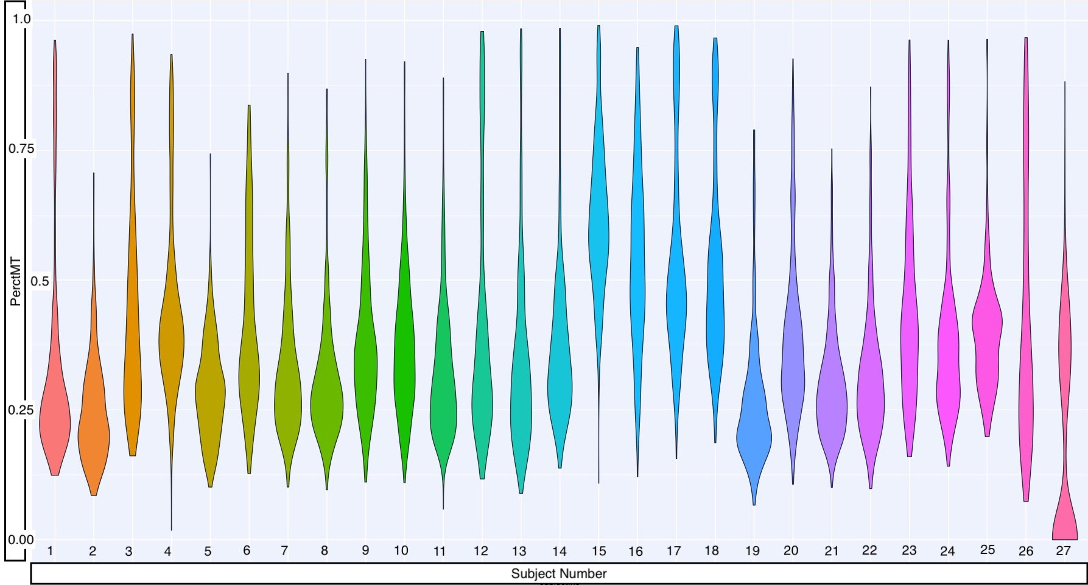

**Figure A1:** Pre-QC **PerctMT** Distribution for each subject

The QC measure thresholds employed by Arazi, Rao, Berthier, et al. in [3] are: 1. 1*,* 000 *<* **nFeature** *<* 5*,* 000

2. **PerctMT** *≤* 25%

All observations for which the calculated values of **nFeature** and **PerctMT** satisfied the inequalities in (1) and (2) above were kept, and the others were considered “low-quality” and removed. The resulting distribution of the **PerctMT** variable is displayed in (**Figure A2**):

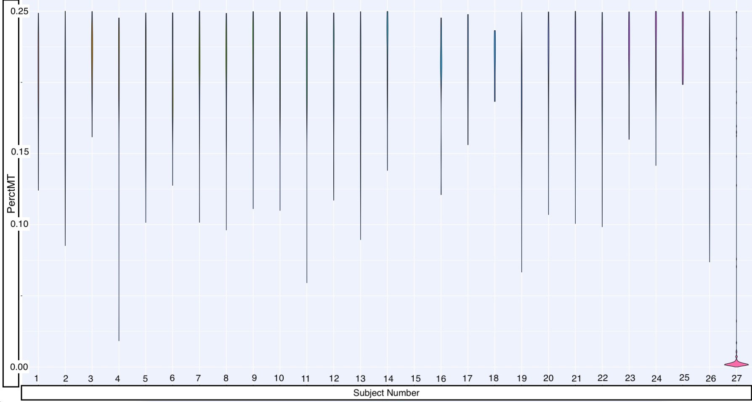

###### **Figure A2:** Post QC distribution of **PerctMT** with thresholds implemented by Arazi, Rao, Berthier, et al

As 84% of cells as removed with the filters chosen by Arazi et al, I choose a more lenient threshold, removing observations with **PerctMT** *≤* 60%, in an effort to keep more cells.

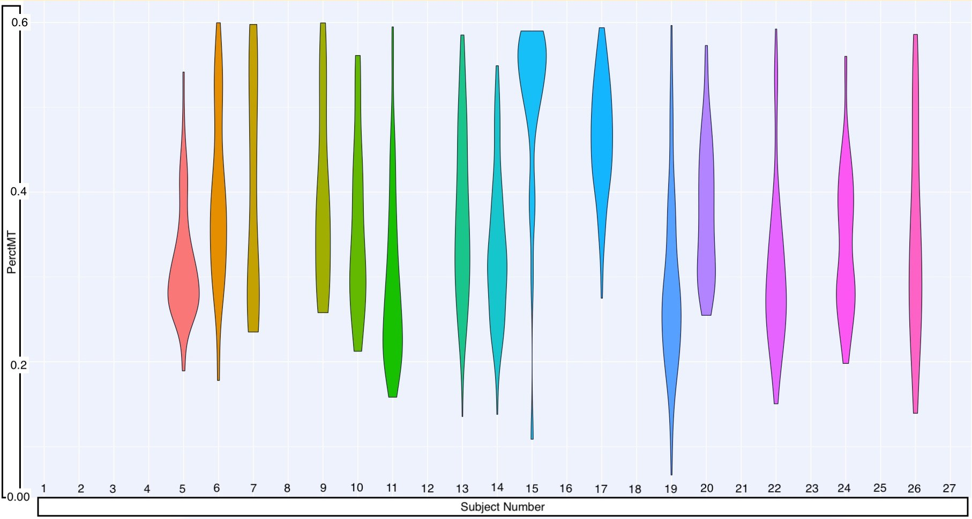An additional restriction of the data to only B-cells is made in an effort to regularize the data sample (i.e. homogenize feature expression). The resulting distribution of **PerctMT** is displayed in (**Figure A3**) after filtering.

**Figure A3:** Post QC distribution of **PerctMT** with thresholds implemented in this paper

The distribution of observations for each subject Pre/Post QC (with updated

**PerctMT** *≤* 60% threshold value) is shown numerically in (**Table A1**):

|  |  |  |  |  |  |  |  |  |  |
| --- | --- | --- | --- | --- | --- | --- | --- | --- | --- |
| **Subject Number** | **1** | **2** | **3** | **4** | **5** | **6** | **7** | **8** | **9** |
| **NO of Obs Before QC** | 375 | 375 | 364 | 381 | 340 | 383 | 383 | 356 | 372 |
| **NO of Obs After QC** | 0 | 0 | 0 | 0 | 58 | 86 | 32 | 0 | 31 |
| **Subject Number** | **10** | **11** | **12** | **13** | **14** | **15** | **16** | **17** | **18** |
| **NO of Obs Before QC** | 327 | 311 | 379 | 375 | 345 | 371 | 381 | 381 | 377 |
| **NO of Obs After QC** | 21 | 107 | 0 | 107 | 100 | 25 | 0 | 122 | 0 |
| **Subject Number** | **19** | **20** | **21** | **22** | **23** | **24** | **25** | **26** | **27** |
| **NO of Obs Before QC** | 380 | 381 | 380 | 333 | 333 | 239 | 218 | 378 | 342 |
| **NO of Obs After QC** | 127 | 75 | 0 | 87 | 0 | 79 | 0 | 53 | 0 |

**Table A1:** Observation counts per-subject Pre/Post QC with updated **PerctMT** *≤* 60% threshold value.

|  |  |  |  |  |  |
| --- | --- | --- | --- | --- | --- |
| MIN | 1st Q | Median | Mean | 3rd Q | MAX |
| 21 | 42.5 | 79 | 74.0 | 103.5 | 127 |

**Table A2:** observation count per-subject summary statistics Post QC with updated

**PerctMT** *≤* 60% threshold value

## Appendix B: Variable Selection and Summaries

I select two pairs of variables from the 38,354 genetic markers in the Lupus Data to compare across the five modeling methods. The variables I choose have higher values of correlation than arbitrary variable pairings as indicated by a high Pearson Correlation Coefficient (both selected pairings are within the top 10% of highest Pearson Correlation Coefficients of all possible pairings), and have previously been associated with human diseases or conditions (e.g. cancer treatment research in the case of MALAT1 [6]-used as the first outcome, or observed limb malformations in the case of FBLN1 [7]-used as the second outcome). I also attempt to assign predictor-pairings of interest. The CD19 marker (the predictor paired with MALAT1) is a transmembrane protein encoded by the CD19 gene. The FlowJo cytometry measurements contain CD19 protein readings, so the relationship between CD19 as a predictor and the outcome of interest (MALAT1) can be modeled using proteomic or transcriptomics data. CD34, the predictor which I link with FBLN1 is also a transmembrane protein encoded by a gene, and similarly interesting.

Without undergoing the process of expression normalization, single-cell RNA sequencing data is represented as non-negative integer count values. Higher counts correspond to higher detection frequencies and these detection frequencies can be interpreted as a quantification of the magnitude of expression for a transcriptomic marker (e.g CD19, CD34, MALAT1, FBLN1).

I provide numerical summaries of the four selected variables in **Tables (B3) - (B6)**. Each describes selected variable summary statistics (minimum, maximum, average, and median) for the positive observational count subjects in (**Table A1**).

Measurements of scRNA-seq data are specific to precise transcriptomic targets. This means that single-cell expression profiles (a single observation) can be limited to a small transcriptomic scope.

So while the agglomerated scope of gene expression across a sample is the same as (or broader than)

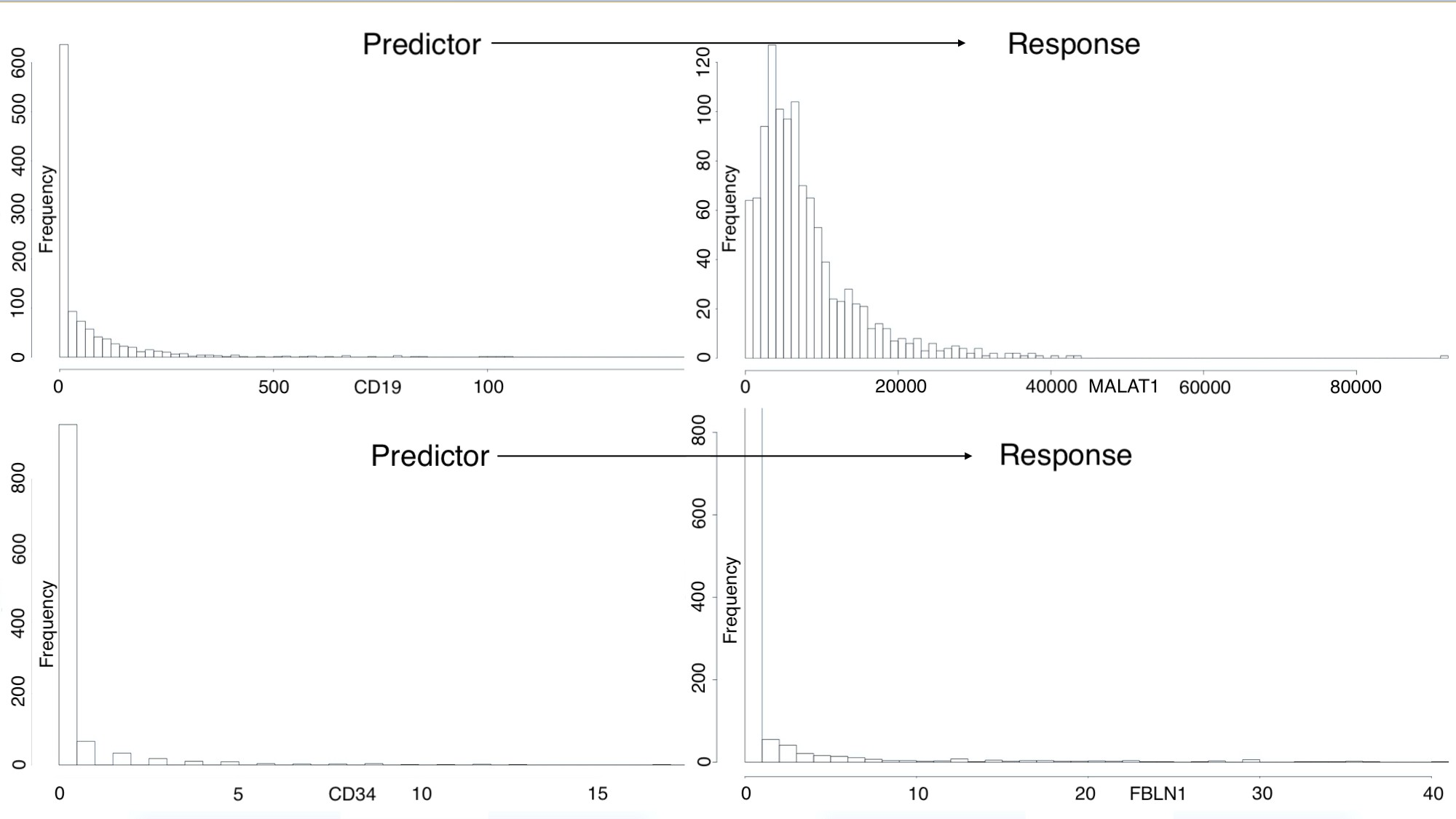a traditional bulk experiment, individual observations have a biologically inflated zero-component. There are also *technical* zero-inflation components that are associated with protocol variations, and measurement error. Together, these factors contribute to right-skewed variable distributions (**Figure B1**)

**Figure B1:** Predictor-Response pairing variable distributions

The MALAT1 variable has a large minimum outcome compared to the other variables, so I translate all the values of this variable *negatively* by the minimum value.

*min*(MALAT1) = 67

This gives a minimum expression value of zero, which coincides with intuition as well as the minimum value of the other variables under investigation.

The modeling methodologies I employ motivate a log-transformation in an attempt to achieve approximate normality, especially for the outcome variable’s distribution. I perform the “log plus

+1” transformation on all variables (predictor and outcome):

*X 1→* log (*X* + 1)

The resulting distributions are shown in (**Figure B2**)

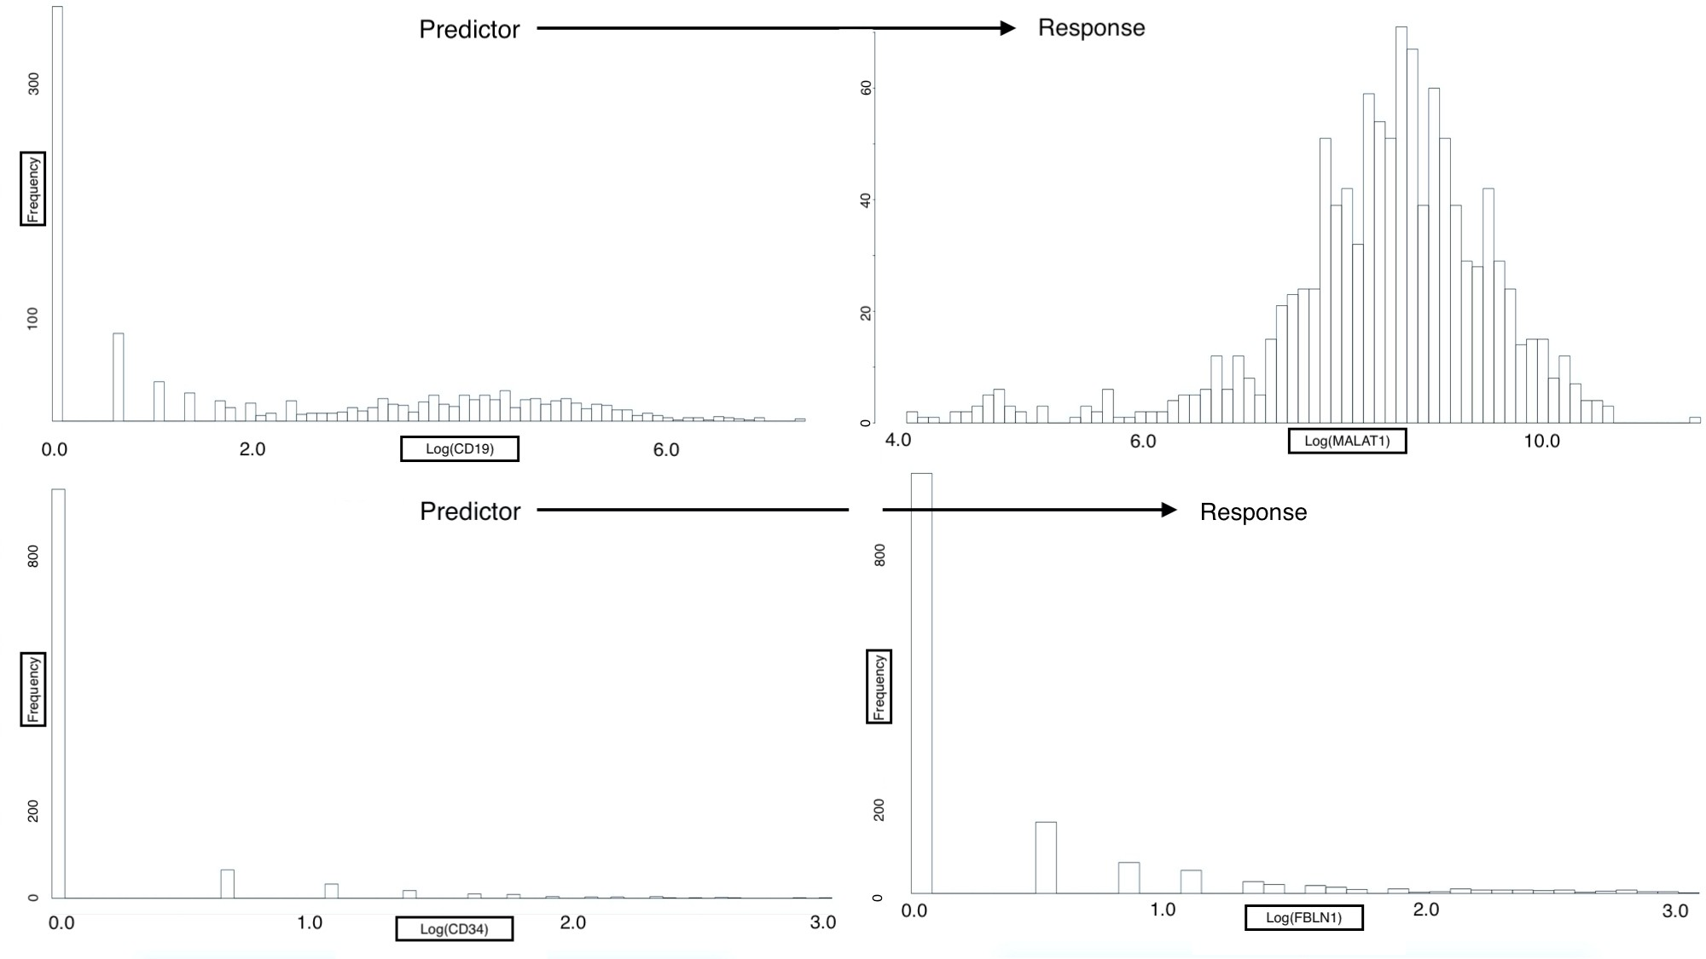

**Figure B2:** Predictor-Response variable pairings, post-transformation distributions

The log-transformed response of MALAT1 is approximately normally distributed; however, the log-transformed response FBLN1 is not inherently better than the un-transformed response.

Regardless, each outcome is modeled under the assumption that: compensating for observational correlation will sufficiently account for non-normality of the responses. It may be the case that additional transformations and/or alternative modeling techniques may be needed to improve model error distributions. However, for the purpose of comparing the previously mentioned models on subject-correlated single-cell data, I proceed with this assumption and I verify residual homoscedasticity, normality and independence using fitted vs residual plots and quantile-quantile plots.

##### Variable Summary Tables

**Tables (B3) - (B6)** are summary tables for the variables chosen in this analysis. The data in each table pertains to a subject that had non-zero post quality control observation counts (i.e. the subject had data that past quality control filters). All values displayed are calculated on post-qc data.

**Table B3: CD19 Summaries**

|  |  |  |  |  |
| --- | --- | --- | --- | --- |
| Subject Number | Minimum | Maximum | Average | Median |
| 5 | 0 | 678 | 36.6724 | 0.0 |
| 6 | 0 | 299 | 36.6860 | 7.5 |
| 7 | 0 | 10 | 2.1250 | 1.0 |
| 9 | 0 | 1052 | 89.4194 | 3.0 |
| 10 | 0 | 158 | 37.5714 | 2.0 |
| 11 | 0 | 339 | 28.3178 | 1.0 |
| 13 | 0 | 629 | 56.0841 | 18.0 |
| 14 | 0 | 251 | 42.2600 | 19.0 |
| 15 | 0 | 148 | 26.6000 | 0.0 |
| 17 | 0 | 982 | 112.3770 | 16.0 |
| 19 | 0 | 665 | 59.3386 | 5.0 |
| 20 | 0 | 287 | 40.1200 | 23.0 |
| 22 | 0 | 380 | 43.4483 | 1.0 |
| 24 | 0 | 282 | 55.0127 | 27.0 |
| 26 | 0 | 1624 | 268.4151 | 110.0 |

**Table B3:** Predictor *CD*19 variable summaries (*CD*19 *∼ M ALAT* 1)

**Table B4: MALAT1 Summaries**

|  |  |  |  |  |
| --- | --- | --- | --- | --- |
| Subject Number | Minimum | Maximum | Average | Median |
| 5 | 67 | 40812 | 10206.3621 | 9195.0 |
| 6 | 757 | 30774 | 11568.2791 | 11689.0 |
| 7 | 441 | 17916 | 6868 | 4039.5 |
| 9 | 311 | 18239 | 5703.9355 | 5983.0 |
| 10 | 1875 | 17160 | 6638.5714 | 6190.0 |
| 11 | 349 | 34082 | 9716.0280 | 8826.0 |
| 13 | 99 | 25572 | 5867.9439 | 4895.0 |
| 14 | 355 | 15740 | 6154.1500 | 5720.5 |
| 15 | 157 | 11923 | 3839.0800 | 3467.0 |
| 17 | 337 | 8342 | 2960.2541 | 2692.0 |
| 19 | 227 | 91961 | 13959.9843 | 10125.0 |
| 20 | 379 | 21736 | 7301.4133 | 6417.0 |
| 22 | 161 | 28429 | 6881.7471 | 5068.0 |
| 24 | 240 | 42792 | 6248.8228 | 5955.0 |
| 26 | 1114 | 32426 | 8463.1698 | 6426.0 |

**Table B4:** Response *MALAT* 1 variable summaries (*CD*19 *∼ MALAT* 1)

**Table B5: CD34 Summaries**

|  |  |  |  |  |
| --- | --- | --- | --- | --- |
| Subject Number | Minimum | Maximum | Average | Median |
| 5 | 0 | 19 | 3.0517 | 1 |
| 6 | 0 | 0 | 0 | 0 |
| 7 | 0 | 0 | 2 | 1 |
| 9 | 0 | 6 | 0.4516 | 0 |
| 10 | 0 | 5 | 0.6667 | 0 |
| 11 | 0 | 7 | 1.2056 | 1 |
| 13 | 0 | 0 | 0 | 0 |
| 14 | 0 | 1 | 0.4000 | 0 |
| 15 | 0 | 0 | 0 | 0 |
| 17 | 0 | 0 | 0 | 0 |
| 19 | 0 | 0 | 0 | 0 |
| 20 | 0 | 2 | 0.1867 | 0 |
| 22 | 0 | 4 | 0.3563 | 0 |
| 24 | 0 | 5 | 0.2911 | 0 |
| 26 | 0 | 0 | 0 | 0 |

**Table B5:** Predictor *CD*34 variable summaries (*CD*34 *∼ FBLN* 1)

**Table B6:FBLN1 Summaries**

|  |  |  |  |  |
| --- | --- | --- | --- | --- |
| Subject Number | Minimum | Maximum | Average | Median |
| 5 | 3 | 41 | 19.3448 | 18 |
| 6 | 0 | 0 | 0 | 0 |
| 7 | 0 | 16 | 4.2500 | 3 |
| 9 | 0 | 8 | 1.8710 | 1 |
| 10 | 0 | 30 | 11.9524 | 10 |
| 11 | 0 | 8 | 1.5140 | 1 |
| 13 | 0 | 1 | 0.0093 | 0 |
| 14 | 0 | 5 | 0.5700 | 0 |
| 15 | 0 | 1 | 0.0400 | 0 |
| 17 | 0 | 3 | 0.0246 | 0 |
| 19 | 0 | 2 | 0.0157 | 0 |
| 20 | 0 | 9 | 2.5867 | 2 |
| 22 | 0 | 11 | 0.9885 | 0 |
| 24 | 0 | 4 | 0.4557 | 0 |
| 26 | 0 | 0 | 0 | 0 |

**Table B6:**: Response *FBLN* 1 variable summaries (*CD*34 *∼ FBLN* 1)

# Code and Data

All code for the above analysis was written and evaluated in RStudio Version 1.2.1335, and is available for download at the following GitHub repository:

<https://github.com/leepanter/MSproject_RBC.git>

Additionally, a link to all necessarry and referrence data files (including original data) are contained in the following Google Drive:

<https://drive.google.com/open?id=1gjHaMJG0Y_kPYWj5bIE4gRJU5z9R2Wqb>

# References

1. Macaulay IC, Voet T (2014) Single cell genomics: Advances and future perspectives. *PLoS genetics* 10: e1004126.
2. Bacher R, Kendziorski C (2016) Design and computational analysis of single-cell rna-sequencing experiments. *Genome biology* 17: 63.
3. Arazi A, Rao DA, Berthier CC, et al. (2018) The immune cell landscape in kidneys of lupus nephritis patients. *bioRxiv* 363051.
4. FlowJo X V10. 0.7 r2 flowjo. *LLC https://www flowjo com*.
5. Hashimshony T, Senderovich N, Avital G, et al. (2016) CEL-seq2: Sensitive highly-multiplexed single-cell rna-seq. *Genome biology* 17: 77.
6. Gutschner T, Hämmerle M, Diederichs S (2013) MALAT1—a paradigm for long noncoding rna function in cancer. *Journal of molecular medicine* 91: 791–801.
7. Debeer P, Schoenmakers E, Twal W, et al. (2002) The fibulin-1 gene (fbln1) is disrupted in at (12; 22) associated with a complex type of synpolydactyly. *Journal of medical genetics* 39: 98–104.
8. Fitzmaurice GM, Laird NM, Ware JH (2012) Applied longitudinal analysis, John Wiley & Sons.
9. Odueyungbo A, Browne D, Akhtar-Danesh N, et al. (2008) Comparison of generalized estimating equations and quadratic inference functions using data from the national longitudinal survey of children and youth (nlscy) database. *BMC medical research methodology* 8: 28.
10. Satija R, others (2018) Seurat: Guided clustering tutorial. *Satija Lab* [*http://satijalab*](http://satijalab/) *org/seurat/pbmc3k_tutorial html*.